Historical Association, Essex Branch
Programme 2021-22
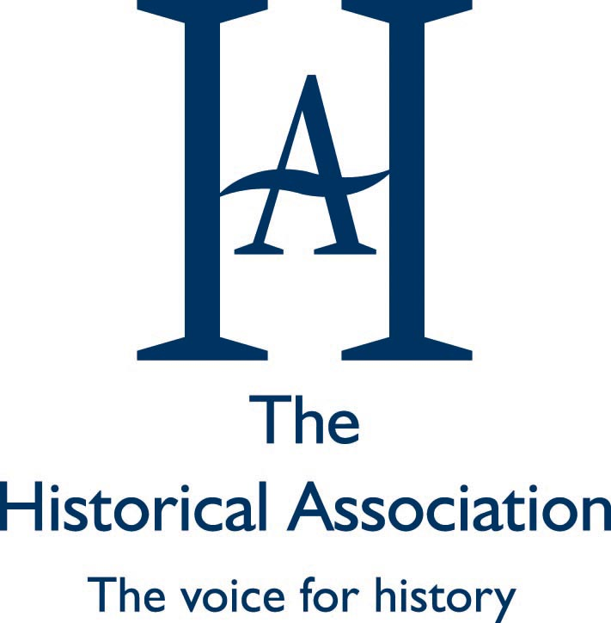

Talks on Saturdays, 2.30pm, Trinity Methodist Church,
Rainsford Road, Chelmsford, CM1 2XB.
Visitors and prospective members warmly welcomed - £3

2021

25 September 1. Annual General Meeting:
No Matter How Many Skies have fallen – Back to the land in wartime Britain
Ken Worpole

23 October 2. Survival of the Princes in the Tower
Matt Lewis – Author and Historian

4 December 3. Historic Houses today: Keeping them meaningful for future generations
Dr. Ben Cowell: Director General of Historic Houses
(Light seasonal refreshments after the talk)

2022

8 January 4. King Charles I – Martyr or Tyrant
Dr. David Smith. Cambridge University

5 February 5. Southend’s Saxon Prince
Sue Hirst: Museum of London Archaeology

5 March 6. Charlemagne
Professor Dame Janet I. Nelson.
Emeritus Professor of Medieval History: Kings College: London

2 April 7. The Trump legacy
Professor Adam Smith. Edward Orsborn Professor of U.S. Politics
and Political History. Oxford University

7 May 8. The Napoleonic Empire
Dr. Michael Rowe: Reader in European History: Kings College: London

For further information: phone 01245 256892
www.history.org.uk http://essexbranchha.blogspot.com

